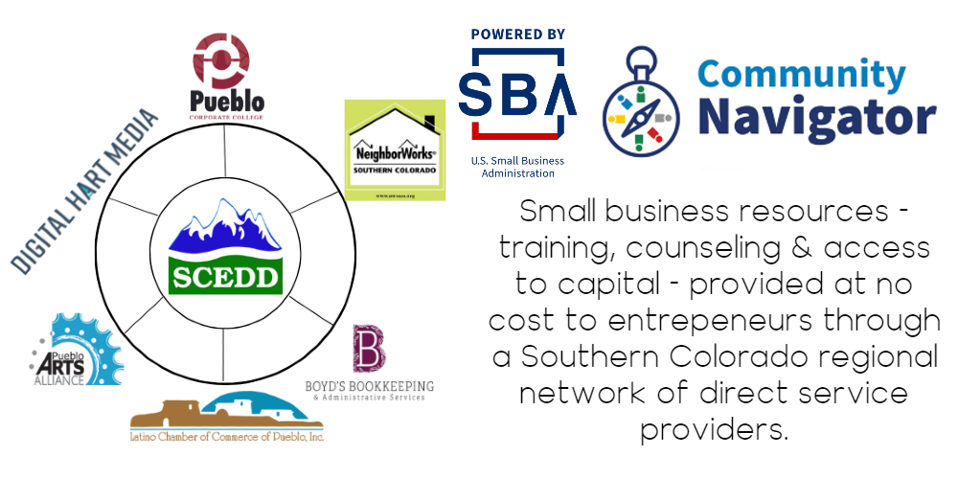
FOR IMMEDIATE RELEASE

DATE: Jan. 24, 2022

CONTACT:
Jacqueline Armendariz Unzueta,
CNPP Co-Director
719-545-8680
jacqueline@scedd.com

Pueblo, CO – The Community Navigator Pilot Program (CNPP) is a $1 million two-year U.S. Small Business Administration grant poised to help Pueblo continue its role as the epicenter of economic activity in the region, while providing increased access to small business direct services throughout Southern Colorado.

The Community Navigator Program is formally launching with a call for the region’s small businesses (500 employees or less) to complete the following short online survey to gauge the current service needs in Southern Colorado: https://bit.ly/2022_SOCO_Navigator_Survey

The Southern Colorado Economic Development District (SCEDD) is the non-profit “hub” of the Community Navigator Program working with its “spokes,” a model inspired by similar successful efforts in the healthcare field. This means SCEDD functions as the grant holder hub, while working collaboratively with its spokes to provide direct service via training, counseling, and assistance with access to capital at no-cost to underserved small businesses. SCEDD serves a 13-county region that includes the frontier Eastern Plains, where access to small business direct service options is more challenging to find.
SCEDD is proud to announce the additional members of the Community Navigator Program in Southern Colorado:

Pueblo Corporate College | NeighborWorks Southern Colorado (the region’s first federally designated Community Development Financial Institution - CDFI) |Boyd’s Bookkeeping & Administrative Services |Latino Chamber of Commerce of Pueblo, Inc. |Pueblo Arts Alliance | Digital Hart Media
All program organizations are considered Navigators whose role is to connect entrepreneurs to services within the program via intra-network referrals or to other relevant resources in the region.

Navigators help assess whether the program might assist a business with a consultation to optimize their website or a training session for a bookkeeping department, for example.

The overall scope of services within the Navigator Program includes:
- Custom training programs
- Access to technical assistance or consulting in:
  - Financial services
  - Online platform optimization
  - Cyber security
  - Marketing
  - Business start-ups
- Specialized technical assistance for creative industry businesses
- Assistance with access to capital

The SBA created the Navigator Program to further maximize its efforts, leverage all possible resources, and have the greatest reach for the U.S. small business ecosystem. Almost 21 percent of the country’s nearly 8 million small businesses are in counties without any type of SBA service center. The 13 Counties SCEDD serves are: Pueblo, Lake, Chaffee, Fremont, Custer, Huerfano, Las Animas, Crowley, Otero, Bent, Baca, Kiowa, and Prowers.

To request Navigator Program assistance, visit www.scedd.com and submit the Navigator Program client intake survey. Please call SCEDD at 719-545-8680 or email info@scedd.com if accessibility assistance is needed.
###

